XRY, the self-adhesive lead wallpaper for noise insulation and radiation protection in dry construction
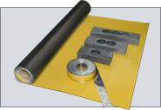
New for dry construction: XRY, the self-adhesive lead wallpaper for noise insulation and radiation protection. Easy to use and versatile, the XRY product range provides efficient and professional solutions for noise and radiation protection construction projects. XRY is pure lead in a roll. It is self-adhesive and adheres to both new and old surfaces as well as around curves and rounded edges. It is perfect for large areas and is ideal for complex room shapes. XRY is an innovation from Germany, from the leading manufacturer of lead semi-finished goods in Europe.

Product range
XRY comes in four thicknesses. The specially finished surfaces fulfil even the strictest hygiene requirements. Extra supplies include self-adhesive strips and covers as well as cavity wall switch boxes. XRY is also available in a separate industrial range.
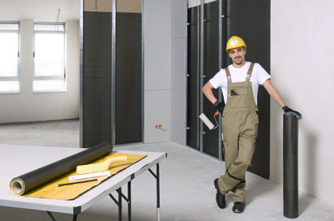
Advantages at a glance
- Easy to use and install with self-adhesive adhesive coating
- Trouble-free installation, even in complex rooms
- Adheres to rough surfaces
- Can be papered over
- Construction panels can be self-laminated on site
- Compact 620 mm roll format for easy handling and reduced setup times
- Full-surface coating for additional hygiene protection
- Higher shielding thickness can be achieved through repeated layering
- Thicker lead layer provides space-saving benefits
- The material thickness is manufactured with a large tolerance range to ensure radiation protection

Product structure
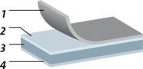
- Protective film
- Glue
- Lead sheet
Base material: Pb 99,94 Cu acc. to DIN EN 17640
- Finishing
Painted surface

Laying
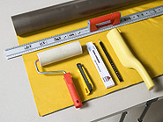 |  | As easy as wallpapering:
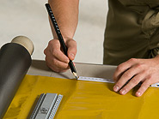 |  | mark out,
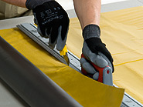 |  | cut,
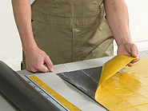 |  | remove ...
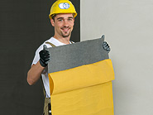 |  | ... the protective film,
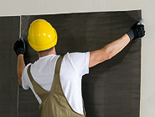 |  | hold in place,
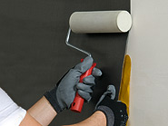 |  | roll firmly, secure, finished!
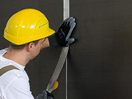 |  | Self-adhesive lead strips are available for circuit joins.
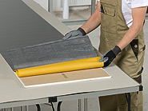 |  | Versatile:  laminating GK-sheets yourself is no problem with XRY

Solutions for effective radiation protection
For lead profiles, lead granulate or lead containers, we offer a wide range of very varied radiation protection solutions using lead:
- Lead bricks
- Lead profiles
- Lead sheets / rolled lead blanks 120142715
- Lead wool
- Lead granulate
- Flexible lead mats
- Sinks
- Castings
- Extrusion pressed parts
- Lead containers
- Self-Adhesive Lead Strips
- Custom products
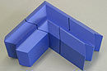

Lead bricks
For building walls, roofs and floors. Lead bricks are now included in DIN EN 25407.
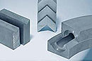

Lead profiles
Prismatically ridged profiles provide an alternative to lead bricks. One of the advantages of these profiles is that different thicknesses can be combined.
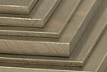

Lead sheets / rolled lead blanks
Mainly used for laying in floors and roofs. If necessary in construction, the specified radiation protection (overall thickness) can be satisfied by laying filling for joins.
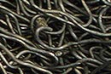

Lead wool
This material is used to produce our flexible radiation protection mats and as shielding for hard to reach areas.
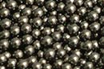

Lead granulate
This material is most suitable for cold filling of shielding containers. A specific weight of approx. 6.6 kg/dm3 is required. Lead granulate "S" uses layered filling of 10mm balls and fine pieces with a particle size of 0.4 – 0.8 mm to achieve a specific weight of 9.25 kg/dm3.
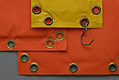

Flexible lead mats
Suitable for producing mobile radiation protection walls because of their flexibility for enveloping defective pipes.
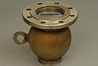

Sinks
as a counterpart for cold filling. The product we manufacture is virtually free of cavities. We can produce items of practically any weight.
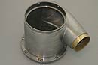

Castings
Produced according to customer specifications. If you wish, we can carry out mechanical processing after production.
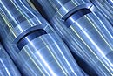

Extrusion pressed parts
For shielding X-ray pipes, for example. The material employed reaches its maximum density through the pressing process.
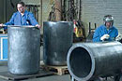

Lead containers
For the transport and storage of radioactive materials. This covers both containers for nuclear medicine and for disposal of radioactive waste from nuclear installations.
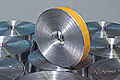

Self-Adhesive Lead Strips
In addition to these products we produce self-adhesive lead strips of different thicknesses for covering joints.

Custom products
Our clients can take advantage of our modern tool production and innovative manufacturing options for the special requirements of radiation protection.

